**Exp No: 7 Date: 11/09/2024**

**CLOUD SIMULATION**

**MODEL CLOUD ENVIRONMENT USING CLOUD SIM**

**AIM:**

To model the cloud environment using cloud sim tools.

**PROCEDURE:**

1. Now within the Eclipse window navigate the menu: File -> New -> Project, to open the new project wizard.
2. Select the ‘Java Project’ from the window popup and click Next.
3. Unselect the ‘Use default location’ option and then click on ‘Browse’ to open the path where you have unzipped the Cloud Sim project and finally click Next to set project

settings.

1. Now select the example program from folder examples from the unzipped folder.
2. Run the sample program

**OUTPUT:**

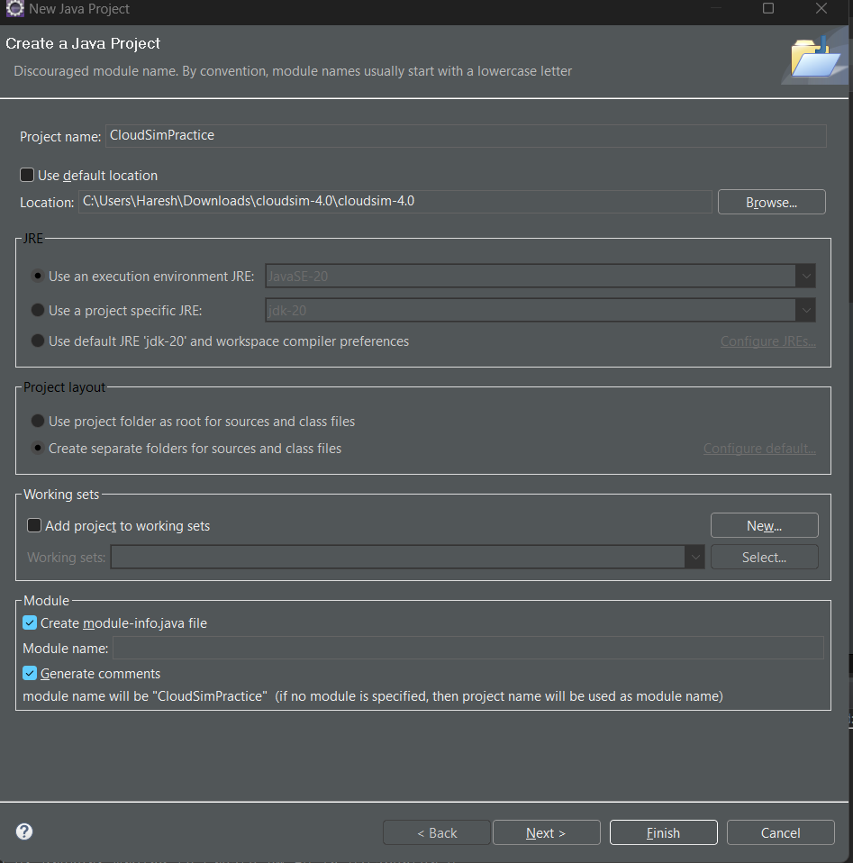

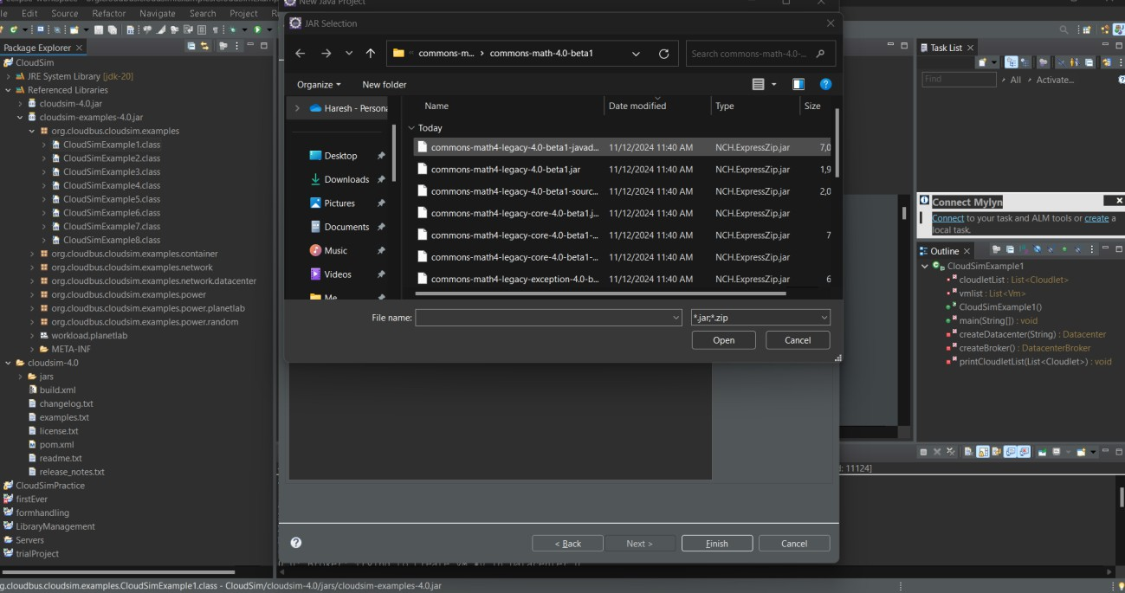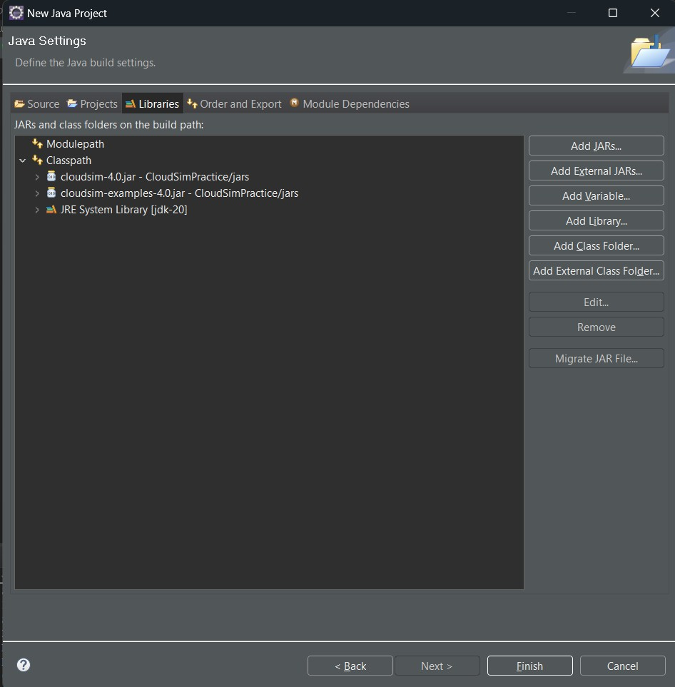

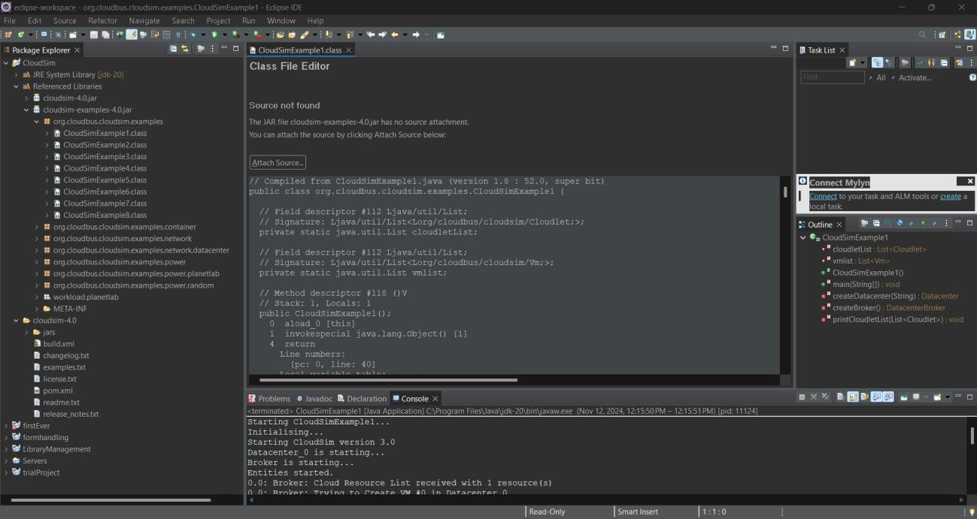

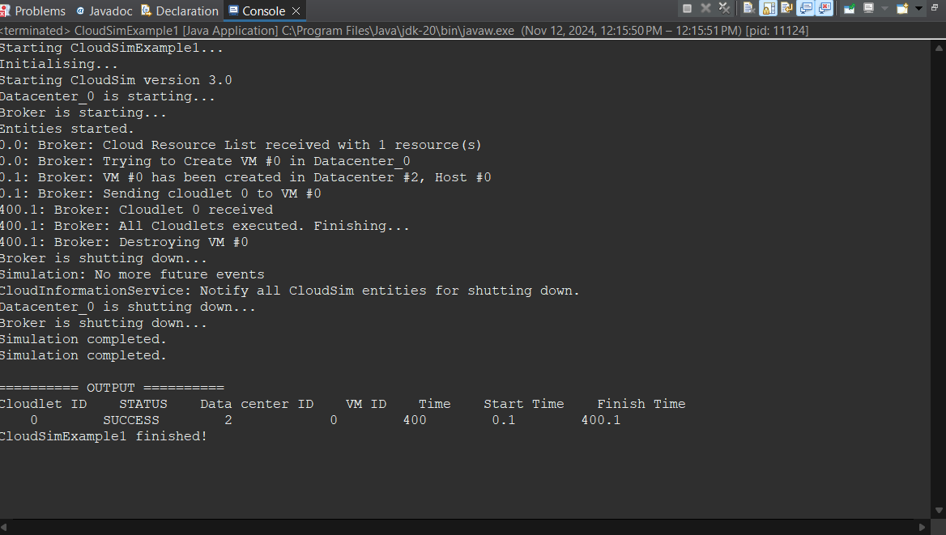

**RESULT:**

Cloud environment has been successfully modelled using cloud sim tools.